Kindergarten Kiddos Newsletter
November 5-9
Reading is part of our daily homework. Please listen to your child read and/or read to your child daily for a minimum of 15 minutes. Please track your child’s reading on an APPLE CORE bookmark provided by the Triggs ES Library. In order for your child to be entered into our school wide drawing for a chance to spin the “Wheel of Prizes,” and the drawing to be invited to the APPLE CORE “Movie of the Month,” a completed APPLE CORE bookmark must be turned in on/before Thursday, November 29th, 2018. Visit the library website TriggsLibrary.weebly.com for more details.  Venture Calendar  Monday, November 5 I Day  Tuesday, November 6 No School Election Day  Wednesday, November 7 No School Conferences  Thursday, November 8 G Day  Friday, November 9 S Day  Our Concept of the Week is Discipline.  Upcoming events:  Tuesday, November 6: No school for Election Day  Wednesday, November 7: No school for conferences  November 1-9: Book Fair in the library  Friday, November 9: PTSO General meeting at 8:15  Friday, November 9: Veterans Day Assembly  Friday, November 9: Fun Friday  Monday, November 11: No school for Veterans Day  November 19-23: No school for Thanksgiving break  Thank you,  Kindergarten Teachers |  |  | Sight Words  Review  a, I, the, like, said, can, am, at, an, and, he, be, we, see, she, to, do, in, is, it, if, did, so, go, no
 |  |  | Teacher’s Corner
Reading Standards | Writing Standards | Math Standards
With prompting and support, retell familiar stories, including details. | We will use a combination of drawing, dictating, and writing to narrate a single event, and tell about the events in order in which they occured, and provide a reaction to what happened. | We will learn how to count numbers to 10. We will count to tell how many and write the numbers to show how many.

Name: | Kindergarten homework for the week of November 5-9
Reading is part of our daily homework. Please listen to your child read and/or read to your child daily for a minimum of 15 minutes. Please track your child’s reading on an APPLE CORE bookmark provided by the Triggs ES Library. In order for your child to be entered into our school wide drawing for a chance to spin the “Wheel of Prizes,” and the drawing to be invited to the APPLE CORE “Movie of the Month,” a completed APPLE CORE bookmark must be turned in on/before Thursday, November 29th, 2018. Visit the library website TriggsLibrary.weebly.com for more details.
 | Reading/Writing | Math
Mon. | Homework is optional this week. Complete assignments on Freckle and READ. | Freckle  Go to student.freckle.com  Type in first and last name AND class code. OR scan the QR code.  Click on the CHICKEN: From my teacher  Choose at least 2 activities
Tues. |  | Freckle  Go to student.freckle.com  Type in first and last name AND class code. OR scan the QR code.  Click on the CHICKEN: From my teacher  Choose at least 2 activities
Wed. |  | Freckle  Go to student.freckle.com  Type in first and last name AND class code. OR scan the QR code.  Click on the CHICKEN: From my teacher  Choose at least 2 activities
Thur. |  | Freckle  Go to student.freckle.com  Type in first and last name AND class code. OR scan the QR code.  Click on the CHICKEN: From my teacher  Choose at least 2 activities

Freckle Directions

Step 1
https://student.freckle.com

Step 2
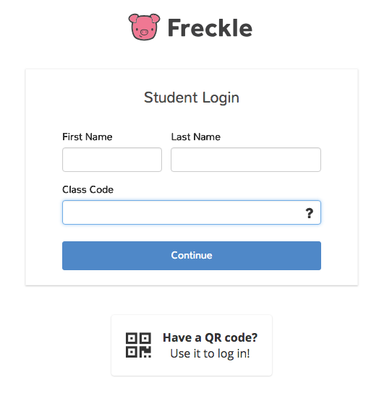
Step 3
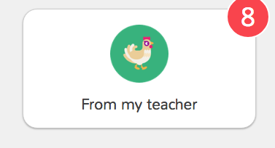

Please do not click on the Lion or the Mouse

