Kindergarten Kiddos Newsletter
April 24-28
Week 31  Venture Calendar  Monday, April 24 G Day  Tuesday, April 25 S Day  Wednesday, April 26 V Day  Thursday, April 27 T Day  Friday, April 28 R Day  Upcoming Events  Tuesday, April 25th is Kindergarten Round Up for those who need to enroll kinder kids for the 2017-2018 school year. Please spread the word if you know anyone with a child who will be entering kindergarten next school year..  Tuesday, April 25th is Raising Cane's Night.  Friday, April 28th is Kindergarten Promotion Picture Day!  Thursday, May 4th is Star Wars Day. Wear something with Star Wars on it. May the Fourth Be with You!  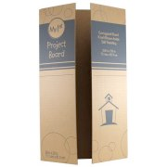  The Triggs’ annual Academic Fair is taking place on Wednesday, May 24th. In preparation for this fun and exciting night, we are asking for tri-fold display boards. The board can be any brand and any color. Please see the picture below as a reference. You can purchase these boards at Target, The Dollar Tree, Wal-Mart, Hobby Lobby, and on-line. We would like for every kindergarten student to have a board by Friday, May 5th. PLEASE DO NOT WRITE ANYTHING ON THE BOARDS.  Thank you,  Kindergarten Teachers |  |  | Sight Words  before  because
Character Trait of the week:

Conscientiousness

 |  |  | Please have your child complete two rounds of fact practice on Front Row each day.
Reading Standards | Writing Standards | Math Standards
We will be able to ask and answer questions about unknown words in a text. | We will be able to use a combination of drawing, dictating, and writing to compose informative/explanatory texts in which we name what we are writing about and supply some information about the topic. | - We will compare length of objects using nonstandard measurement. We will also be able to compare objects with measurable attributes.

Name: | Kindergarten homework for the week of April 24-28

 | Reading/Writing | Math
Mon. | Tell a family member three things you learned about Earth. Write those ideas in complete sentences.  Check for capitals, spacing, end punctuation, and make sure it makes sense. | Front Row  Complete 2 rounds of fact practice.  Go to Math. Click on Fact Practice.  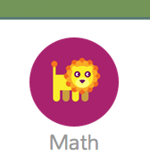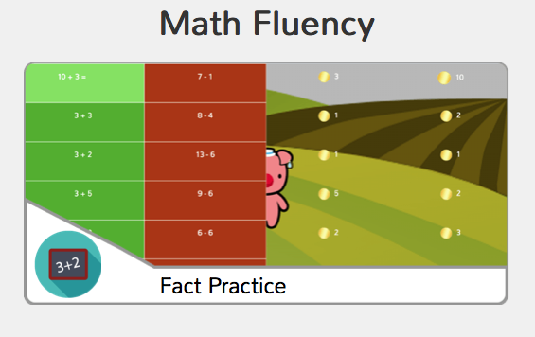
Tues. | Write the sight word before 10 times.  Parents, please make sure your child uses all lowercase letters.  Challenge: Write two sentences using the word before. | Front Row  Complete 2 rounds of fact practice.  Go to Math. Click on Fact Practice.
Wed. | Write the sight word because 10 times.  Parents, please make sure your child uses all lowercase letters.  Challenge: Write two sentences using the word because. | Front Row  Complete 2 rounds of fact practice.  Go to Math. Click on Fact Practice.
Thurs. | Tomorrow we are retesting address and phone number.  Write your phone number 10 times and tell it to a family member with your eyes closed. | Front Row  Complete 2 rounds of fact practice.  Go to Math. Click on Fact Practice.

