Kindergarten Kiddos Newsletter
May 8-12
Week 33  Venture Calendar  Monday, May 8 R Day  Tuesday, May 9 I Day  Wednesday, May 10 G Day  Thursday, May 11 S Day  Friday, May 12 V Day  This week’s homework will be research for the career your child chose to share for the Triggs’ Annual Academic Fair.  Upcoming Events  Friday, May 12 is Kindergarten Family Day at 2:15.  Friday, May 26 is Career Day. More information about this day will come home soon.  Wednesday, May 31 is the Academic Fair.  Thank you,  Kindergarten Teachers |  |  | Sight Words  None this week.
Character Trait of the week:

Tolerance
Your child chose the career

_____________________

for academic night.

Reading Standards | Writing Standards | Math Standards
We will be able to ask and answer questions about unknown words in a text. | Participate in shared research and writing project.  With guidance and support from adults, explore a variety of digital tools to produce and publish writing, including in collaboration with peers. | - Compose and decompose numbers from 11 to 19 into ten ones and some further ones, e.g., by using objects or drawings, and record each composition or decomposition by a drawing or equation (e.g., 18 = 10 + 8); understand that these numbers are composed of ten ones and one, two, three, four, five, six, seven, eight, or nine ones.

Name: | Kindergarten homework for the week of May 8-12

 | Reading/Writing | Math
Mon. | Tell a family member why you chose your career.  Parents, go online and help your child find 5 images about their career choice. Please print them out if you can. The pictures will be on display for the Academic Fair. If you can not print them out, email or Dojo the link/s to your child’s teacher. | Front Row  Complete 2 rounds of fact practice.  Go to Math. Click on Fact Practice.  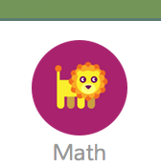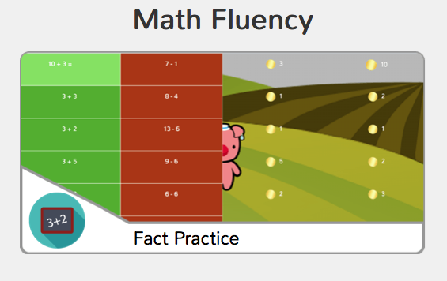
Tues. | Talk with a family member about the career you chose. What are 3 or more tools you will need to be successful? For example, a ballerina will need ballet shoes. A firefighter will need a hose and an ax.  Parents, go online and help your child find images of those tools. Please print them out if you can. If you can not print them out, email or Dojo the link/s to your child’s teacher. | Front Row  Complete 2 rounds of fact practice.  Go to Math. Click on Fact Practice.
Wed. | Continue to find images about the career you chose.  BONUS: Try to bring in real artifacts about your career choice. The artifacts will be on display during the Academic Fair.  For example: actual photographs, clothing, brochures, models…  Please do not send items that are expensive, breakable, or sentimental. | Front Row  Complete 2 rounds of fact practice.  Go to Math. Click on Fact Practice.
Thurs. | Continue to work on Monday - Wednesday’s homework. | Front Row  Complete 2 rounds of fact practice.  Go to Math. Click on Fact Practice.

