Kindergarten Kiddos Newsletter
October 29- November 2
Reading is part of our daily homework. Please listen to your child read and/or read to your child daily for a minimum of 15 minutes. OR Encourage your child to read independently for a minimum of 10 minutes. Please track your child’s reading on the APPLE CORE bookmark provided by the Triggs ES Library. In order for your child to be entered into our school wide drawing for a chance to spin the “Wheel of Prizes,” and a chance to be invited to the APPLE CORE “Movie of the Month,” a completed APPLE CORE bookmark must be turned in on/before Monday, October 29th, 2018. Visit the library website TriggsLibrary.weebly.com for more details.  Venture Calendar  Monday, October 29 I Day  Tuesday, October 30 G Day  Wednesday, October 31 S Day  Thursday, November 1 T Day  Friday, November 2 R Day  Our Concept of the Week is Goal - Oriented.  Students may wear their costumes to school on Halloween. Masks, face paints, and weapons are not allowed.  Upcoming events:  Parent-Student-Teacher Academic Planning Time will be held November 5-9. Please make sure your child attends the conference so they can participate.  Thank you,  Kindergarten Teachers |  |  | Sight Words  so  no  go
Teacher’s Corner

Our school participates in a computer-based program called Freckle. It is a great resource that supports the learning of your child. I will be assigning Freckle as MATH homework. If you DO NOT have access to a computer or tablet, please let me know as soon as possible so I can assign something else.
Reading Standards | Writing Standards | Math Standards
With prompting and support, retell familiar stories, including key details. | We will use a combination of drawing, dictating, and writing to narrate a single event, and tell about the events in order in which they occured, and provide a reaction to what happened. | We will write numbers from 0-20 and understand the relationship between numbers and quantities.We will also count to answer “how many” up to 20 arranged in different ways.

Name: | Kindergarten homework for the week of October 29 - November 2
Reading is part of our daily homework. Please listen to your child read and/or read to your child daily for a minimum of 15 minutes. OR, Encourage your child to read independently for a minimum of 10 minutes. Please track your child’s reading on the APPLE CORE bookmark provided by the Triggs ES Library. In order for your child to be entered into our school wide drawing for a chance to spin the “Wheel of Prizes,” and a chance to be invited to the APPLE CORE “Movie of the Month,” a completed APPLE CORE bookmark must be turned in on/before Monday, October 29th, 2018. Visit the library website TriggsLibrary.weebly.com for more details.
 | Reading/Writing | Math
Mon. | Walk around your home and find things that begin with the /Dd/ sound.  Draw a picture for five of those things.  Challenge: Write the name for each picture. | Freckle  Go to student.freckle.com  Type in first and last name AND class code. OR scan the QR code.  Click on the CHICKEN: From my teacher  Choose at least 2 activities
Tues. | Walk around your home and find things that begin with the /Gg/ sound.  Draw a picture for five of those things.  Challenge: Write the name for each picture. | Freckle  Go to student.freckle.com  Type in first and last name AND class code. OR scan the QR code.  Click on the CHICKEN: From my teacher  Choose at least 2 activities
Wed. | Sight word practice  Complete the handwriting page for so, no and go. Use your very best handwriting.  Parents, please watch your child closely. Make sure he/she is writing the letters from TOP to BOTTOM. Also make sure your child says each letter and READS the word. | Freckle  Go to student.freckle.com  Type in first and last name AND class code. OR scan the QR code.  Click on the CHICKEN: From my teacher  Choose at least 2 activities
Thur. | Think, Draw, and Write  THINK of something you would like to write about.  DRAW a picture of your thinking.  Say out loud what you are thinking and drawing about.  WRITE a sentence about your thinking. | Freckle  Go to student.freckle.com  Type in first and last name AND class code. OR scan the QR code.  Click on the CHICKEN: From my teacher  Choose at least 2 activities
Freckle Directions

Step 1
https://student.freckle.com

Step 2
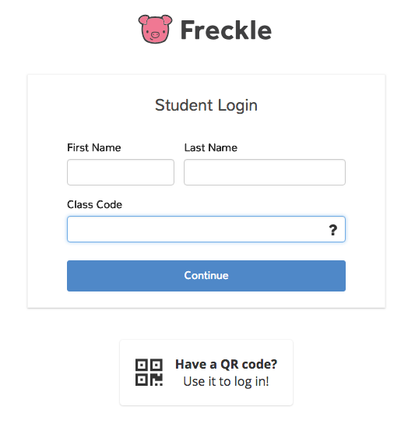
Step 3
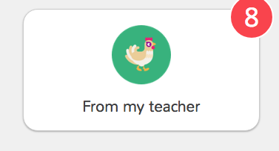

Please do not click on the Lion or the Mouse

